 |  | The Bohr Model http://csep10.phys.utk.edu/astr162/lect/light/bohr.html

The most important properties of atomic and molecular structure may be exemplified using a simplified picture of an atom that is called the Bohr Model. This model was proposed by Niels Bohr in 1915; it is not completely correct, but it has many features that are approximately correct and it is sufficient for much of our discussion. The correct theory of the atom is called quantum mechanics; the Bohr Model is an approximation to quantum mechanics that has the virtue of being much simpler. (Here is a more realistic discussion of what atomic orbitals look like in quantum mechanics.)

A Planetary Model of the Atom
The Bohr Model is probably familiar as the "planetary model" of the atom illustrated in the adjacent figure that, for example, is used as a symbol for atomic energy (a bit of a misnomer, since the energy in "atomic energy" is actually the energy of the nucleus, rather than the entire atom). In the Bohr Model the neutrons and protons (symbolized by red and blue balls in the adjacent image) occupy a dense central region called the nucleus, and the electrons orbit the nucleus much like planets orbiting the Sun (but the orbits are not confined to a plane as is approximately true in the Solar System). The adjacent image is not to scale since in the realistic case the radius of the nucleus is about 100,000 times smaller than the radius of the entire atom, and as far as we can tell electrons are point particles without a physical extent.
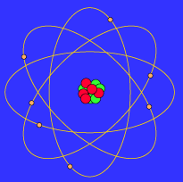
The Bohr atom
This similarity between a planetary model and the Bohr Model of the atom ultimately arises because the attractive gravitational force in a solar system and the attractive Coulomb (electrical) force between the positively charged nucleus and the negatively charged electrons in an atom are mathematically of the same form. (The form is the same, but the intrinsic strength of the Coulomb interaction is much larger than that of the gravitational interaction; in addition, there are positive and negative electrical charges so the Coulomb interaction can be either attractive or repulsive, but gravitation is always attractive in our present Universe.)

But the Orbits Are Quantized
The basic feature of quantum mechanics that is incorporated in the Bohr Model and that is completely different from the analogous planetary model is that the energy of the particles in the Bohr atom is restricted to certain discrete values. One says that the energy is quantized. This means that only certain orbits with certain radii are allowed; orbits in between simply don't exist.
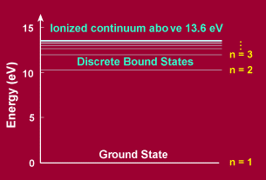
Quantized energy levels in hydrogen
The adjacent figure shows such quantized energy levels for the hydrogen atom. These levels are labeled by an integer n that is called a quantum number. The lowest energy state is generally termed the ground state. The states with successively more energy than the ground state are called the first excited state, the second excited state, and so on. Beyond an energy called the ionization potential the single electron of the hydrogen atom is no longer bound to the atom. Then the energy levels form a continuum. In the case of hydrogen, this continuum starts at 13.6 eV above the ground state ("eV" stands for "electron-Volt", a common unit of energy in atomic physics).
Although this behavior may seem strange to our minds that are trained from birth by watching phenomena in the macroscopic world, this is the way things behave in the strange world of the quantum that holds sway at the atomic level.

Atomic Excitation and De-excitation
Atoms can make transitions between the orbits allowed by quantum mechanics by absorbing or emitting exactly the energy difference between the orbits. The following figure shows an atomic excitation cause by absorption of a photon and an atomic de-excitation caused by emission of a photon.
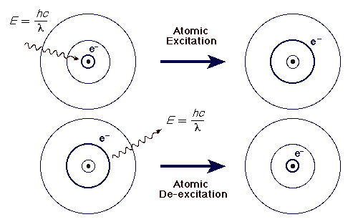
Excitation by absorption of light and de-excitation by emission of light

In each case the wavelength of the emitted or absorbed light is exactly such that the photon carries the energy difference between the two orbits. This energy may be calculated by dividing the product of the Planck constant and the speed of light hc by the wavelength of the light). Thus, an atom can absorb or emit only certain discrete wavelengths (or equivalently, frequencies or energies).
Here is a Shockwave movie of atomic absorption and emission (requires the Flash 2 Shockwave Plugin, which is available for free from Macromedia for Windows and Macintosh systems). Here is a Java applet illustrating atomic absorption and emission.

Atomic Absorption and Emission Spectra
http://csep10.phys.utk.edu/astr162/lect/light/absorption.html

As we have noted in the section on the Bohr atom, isolated atoms can absorb and emit packets of electromagnetic radiation having discrete energies dictated by the detailed atomic structure of the atoms. When the corresponding light is passed through a prism or spectrograph it is separated spatially according to wavelength, as illustrated in the following image.
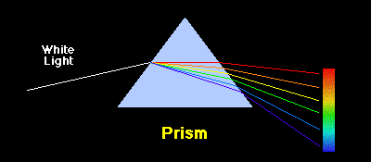
Separation of light by a prism according to wavelength

Continuum, Emission, and Absorption Spectra
The corresponding spectrum may exhibit a continuum, or may have superposed on the continuum bright lines (an emission spectrum) or dark lines (an absorption spectrum), as illustrated in the following figure.
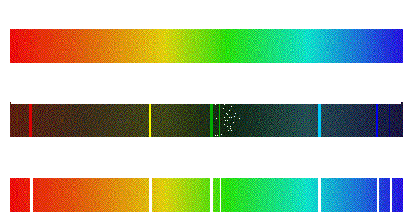
Continuous, emission, and absorption spectra

Origin of Continuum, Emission, and Absorption Spectra
The origins of these three types of spectra are illustrated in the following figure.
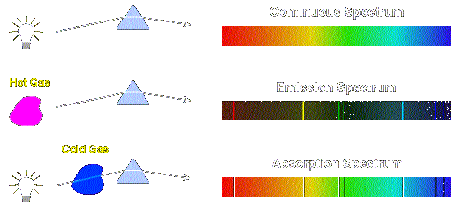
Sources of continuous, emission, and absorption spectra
Thus, emission spectra are produced by thin gases in which the atoms do not experience many collisions (because of the low density). The emission lines correspond to photons of discrete energies that are emitted when excited atomic states in the gas make transitions back to lower-lying levels.
A continuum spectrum results when the gas pressures are higher. Generally, solids, liquids, or dense gases emit light at all wavelengths when heated.
An absorption spectrum occurs when light passes through a cold, dilute gas and atoms in the gas absorb at characteristic frequencies; since the re-emitted light is unlikely to be emitted in the same direction as the absorbed photon, this gives rise to dark lines (absence of light) in the spectrum.

Hydrogen Emission and Absorption Series
The spectrum of hydrogen is particularly important in astronomy because most of the Universe is made of hydrogen. Emission or absorption processes in hydrogen give rise to series, which are sequences of lines corresponding to atomic transitions, each ending or beginning with the same atomic state in hydrogen. Thus, for example, the Balmer Series involves transitions starting (for absorption) or ending (for emission) with the first excited state of hydrogen, while the Lyman Series involves transitions that start or end with the ground state of hydrogen; the adjacent image illustrates the atomic transitions that produce these two series in emission.
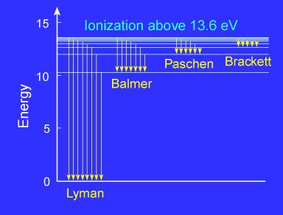
Hydrogen emission series
Because of the details of hydrogen's atomic structure, the Balmer Series is in the visible spectrum and the Lyman Series is in the the UV. The following image illustrates some of the transitions in the Balmer series.
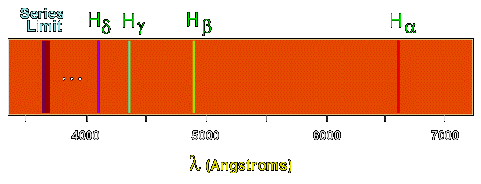
The Balmer spectrum of hydrogen

The Balmer lines are designated by H with a greek subscript in order of decreasing wavelength. Thus the longest wavelength Balmer transition is designated H with a subscript alpha, the second longest H with a subscript beta, and so on.

Electron Transitions
The Bohr model for an electron transition in hydrogen between quantized energy levels with different quantum numbers n yields a photon by emission with quantum energy:
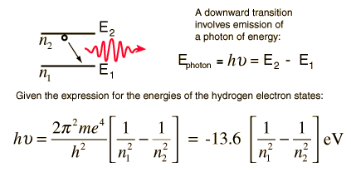
This is often expressed in terms of the inverse wavelength or "wave number" as follows:
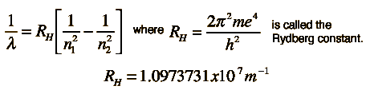

Quantized Energy States
The electrons in free atoms can will be found in only certain discrete energy states. These sharp energy states are associated with the orbits or shells of electrons in an atom, e.g., a hydrogen atom. One of the implications of these quantized energy states is that only certain photon energies are allowed when electrons jump down from higher levels to lower levels, producing the hydrogen spectrum. The Bohr model successfully predicted the energies for the hydrogen atom, but had significant failures that were corrected by solving the Schrodinger equation for the hydrogen atom.
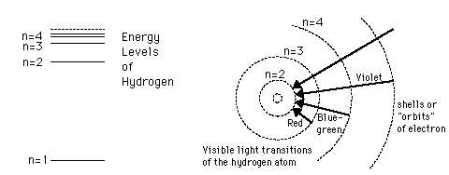

Scaled energy levels

Hydrogen Energy Level Plot
The basic structure of the hydrogen energy levels can be calculated from the Schrodinger equation. The energy levels agree with the earlier Bohr model, and agree with experiment within a small fraction of an electron volt.
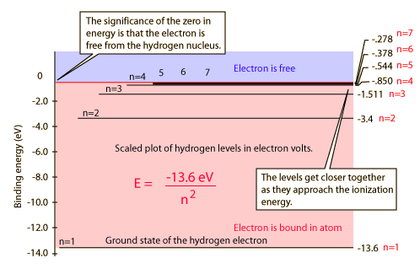

If you look at the hydrogen energy levels at extremely high resolution, you do find evidence of some other small effects on the energy. The 2p level is split into a pair of lines by the spin-orbit effect. The 2s and 2p states are found to differ a small amount in what is called the Lamb shift. And even the 1s ground state is split by the interaction of electron spin and nuclear spin in what is called hyperfine structure.

Ionization and Plasmas
Atoms and molecules are electrically neutral in that the number of negatively charged electrons is exactly equal to the number of positively charged protons. Much of the "normal matter" that we find around us is in this form. However, particularly when there are energy sources available, atoms or molecules can gain or lose electrons and acquire a net electrical charge. This process is called ionization.

Ionization of Atoms
Ionization is the gain or loss of electrons. The loss of electrons, which is the more common process in astrophysical environments, converts an atom into a positively charged ion, while the gain of electrons converts an atom into a negatively charged ion. In the subsequent discussion, we will use the terms ionization and ionize in the sense of losing electrons to form positive ions.
There is a standard notation in astrophysics for various levels of ionization of an atom. As illustrated in the following table, this notation uses increasing Roman numerals to indicate higher levels of ionization.
Notation for Degrees of Ionization
Suffix | Ionization | Examples | Chemist's  Notation
I | Not ionized (neutral) | H I, He I | H, He
II | Singly ionized | H II, He II | H⁺, He⁺
III | Doubly ionized | He III, O III | He⁺⁺, O⁺⁺
We also show the standard chemist's notation for such ions, which consists of placing a right superscript on the element symbol indicating the net electrical charge on the ion (in the neutral case the superscript "0" is usually omitted). Thus, for example, we shall speak later of "H II regions", meaning volumes of space in which the radiation from nearby hot stars has completely ionized the hydrogen.

Plasmas
If most of the atoms or molecules in a region are ionized, the resulting state of matter corresponds to a gas that is electrically neutral on a global scale, but composed microscopically of positively charged ions and the negatively charged electrons stripped from the atoms to form the ions. Such a state of matter is called a plasma. Most of the matter in stars is in a plasma state. Thus, although what we refer to as "normal matter" consists of atoms and molecules, the evidence is that the most abundant form of matter in the Universe is not atoms and molecules but rather the plasma state.

Radiation Laws

The average or bulk properties of electromagnetic radiation interacting with matter are systematized in a simple set of rules called radiation laws. These laws apply when the radiating body is what physicists call a blackbody radiator. Generally, blackbody conditions apply when the radiator has very weak interaction with the surrounding environment and can be considered to be in a state of equilibrium. Although stars do not satisfy perfectly the conditions to be blackbody radiators, they do to a sufficiently good approximation that it is useful to view stars as approximate blackbody radiators.

Planck Radiation Law
The primary law governing blackbody radiation is the Planck Radiation Law, which governs the intensity of radiation emitted by unit surface area into a fixed direction (solid angle) from the blackbody as a function of wavelength for a fixed temperature. The Planck Law can be expressed through the following equation.

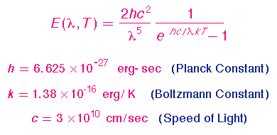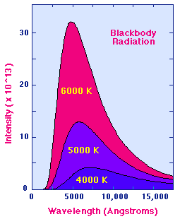
The behavior is illustrated in the figure shown above. The Planck Law gives a distribution that peaks at a certain wavelength, the peak shifts to shorter wavelengths for higher temperatures, and the area under the curve grows rapidly with increasing temperature.

The Wien and Stefan-Boltzmann Laws
The behavior of blackbody radiation is described by the Planck Law, but we can derive from the Planck Law two other radiation laws that are very useful. The Wien Displacement Law, and the Stefan-Boltzmann Law are illustrated in the following equations.
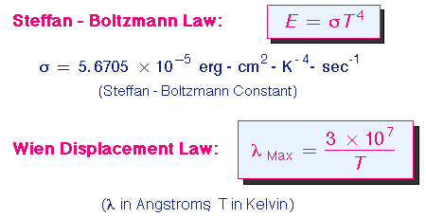
The Wien Law gives the wavelength of the peak of the radiation distribution, while the Stefan-Boltzmann Law gives the total energy being emitted at all wavelengths by the blackbody (which is the area under the Planck Law curve). Thus, the Wien Law explains the shift of the peak to shorter wavelengths as the temperature increases, while the Stefan-Boltzmann Law explains the growth in the height of the curve as the temperature increases. Notice that this growth is very abrupt, since it varies as the fourth power of the temperature.
The following figure illustrates the Wien law in action for three different stars of quite different surface temperature. The strong shift of the spectrum to shorter wavelengths with increasing temperatures is apparent in this illustration.
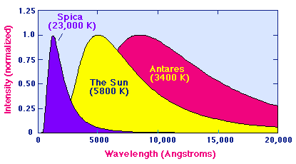

For convenience in plotting these distributions have been normalized to unity at the respective peaks; by the Stefan-Boltzmann Law, the area under the peak for the hot star Spica is in reality 2094 times the area under the peak for the cool star Antares.

Temperatures and Characteristic Wavelengths
By the Planck Law, all heated objects emit a characteristic spectrum of electromagnetic radiation, and this spectrum is concentrated in higher wavelengths for cooler bodies. The following table summarizes the blackbody temperatures necessary to give a peak for emitted radiation in various regions of the spectrum.
Some Blackbody Temperatures
Region | Wavelength  (centimeters) | Energy  (eV) | Blackbody Temperature  (K)
Radio | > 10 | < 10⁻⁵ | < 0.03
Microwave | 10 - 0.01 | 10⁻⁵ - 0.01 | 0.03 - 30
Infrared | 0.01 - 7 x 10⁻⁵ | 0.01 - 2 | 30 - 4100
Visible | 7 x 10⁻⁵ - 4 x 10⁻⁵ | 2 - 3 | 4100 - 7300
Ultraviolet | 4 x 10⁻⁵ - 10⁻⁷ | 3 - 10³ | 7300 - 3 x 10⁶
X-Rays | 10⁻⁷ - 10⁻⁹ | 10³ - 10⁵ | 3 x 10⁶ - 3 x 10⁸
Gamma Rays | < 10⁻⁹ | > 10⁵ | > 3 x 10⁸

Blackbody radiation corresponds to radiation from bodies in thermal equilibrium. We will consider later the emission of non-thermal radiation, which doesn't follow a blackbody law. Such radiation is often produced by violent collisions rather than equilibrium heating. For example, in astrophysical environments radiation at the long and short wavelength ends of the above table is more likely to be produced by non-thermal processes.

Java Virtual Experiments: Blackbody Radiation
Here are three Java applets illustrating some important properties of blackbody radiation.
- The Planck Law
- Wien's Law, Stefan-Boltzmann Law, and Color Indices
- BlackBody: The Game!
You may use these virtual experiments to gain some experience with how Planck distributions evolve with temperature.

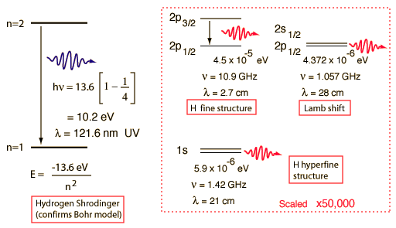

http://library.thinkquest.org/C006669/data/Chem/atomic/spectra.html
Atomic Structure : Atomic Spectra
1814 - Joseph von Fraunhofer
- Studied the absorption spectrum of the light given off by the sun.
  - Absorption Spectrum - The spectrum of dark lines against a light background that results from the absorption of selected frequencies of the electromagnetic radiation by an atom or molecule.
1855-1860 - Robert Bunsen and Gustav Kirchhoff
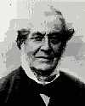 |  | - Developed a spectroscope that focused the light from a burner flame onto a prism that separated the light into its spectrum. Studied the emission spectrum of several metals.  - Emission Spectrum - The spectrum of bright lines against a dark background obtained when an atom or molecule emits radiation when excited by heat or an electric discharge.
Robert Bunsen | Gustav  Kirchhoff
Flame Test
The following metals give emit certain colors of light when their atoms are excited.
Metal |  | Color
Sodium (Na) |  | Yellow
Lithium (Li) |  | Pink/Red
Potassium (K) |  | Purple
Copper (Cu) |  | Green
Calcium (Ca) |  | Pink
Barium (Ba) |  | Yellow/Orange
Strontium (Sr) |  | Red/Orange
1885 - Johann Jacob Balmer
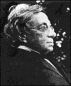 | - Analyzed the hydrogen spectrum and found that hydrogen emitted four bands of light  within the visible spectrum:
  Wavelength (nm) |  | Color
  656.2 |  | red
  486.1 |  | blue
  434.0 |  | blue-violet
  410.1 |  | violet
- Balmer found that the data fit to the following equation:
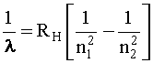
- = wavelength (nm)
- R_{H} = Rydberg's constant = 1.09678 x 10⁻² nm⁻¹
- n₁ = the lower energy level
- n₂ = the higher energy level
For example, to calculate the wavelength of light emitted when the electron in a hydrogen atom falls from the fourth energy level to the second energy level:
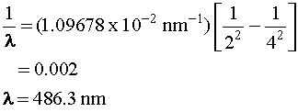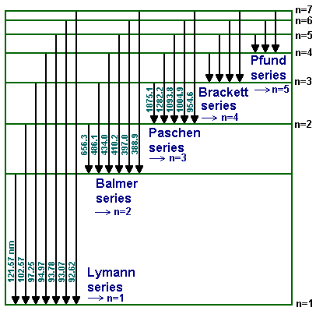
Each series is named after its discoverer.
- The Lyman series is the wavelengths in the ultra violet (UV) spectrum of the hydrogen atom, resulting from electrons dropping from higher energy levels into the n = 1 orbit.
- The Balmer series is the wavelengths in the visible light spectrum of the hydrogen atom, resulting from electrons falling from higher energy levels into the n = 2 orbit.
- The Paschen series is the wavelengths in the infrared spectrum of the hydrogen atom, resulting from electrons falling from higher energy levels into the n = 3 orbit.
- The Brackett series is the wavelengths in the infrared spectrum of the hydrogen atom, resulting from electrons falling from higher energy levels into the n = 4 orbit.
The Pfund series is the wavelengths in the infrared spectrum of the hydrogen atom, resulting from electrons falling from higher energy levels into the n = 5 orbit.
1900 - Max Planck
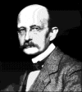 | - Hypothesized that substances were surrounded by oscillating "resonators" which  emitted energy that was quantized, or countable, because he assumed that there  were only a limited number of energies at which these oscillators could exist.
1905 - Albert Einstein
- Extended Planck's work to include light, hypothesizing that light was also quantized.
- He assumed that:
  - Light was made up of small, discrete particles of energy called photons.
  - The energy (E) of a photon is proportional to its frequency (v):
where h is Planck's constant = 6.626 x 10⁻³⁴ J-s.
Next: "Bohr Model"
http://www.dartmouth.edu/~chemlab/chem6/hspect/overview/procedure.html
Overview  Getting Started  Techniques  Procedure  FAQ  Full Lab Manual  Introduction & Goals  Chemistry & Background  Key Questions  Prelab Problems  Safety  Procedure  In Your Write-up  Experiments Index  ChemLab Home
  Spectrum of the Hydrogen Atom
  Atomic Spectra
   |  | The Balmer Series of Hydrogen consists of four visible lines.  The transitions between electron energy levels can be explored using the Atomic Spectra Applet described on the Getting Started page.
   |  | The sodium spectrum consists of one very bright yellow line.  The other colors in the photo are due to scattered light from another source.
  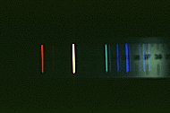 |  | The helium spectrum is somewhat more complex than that of hydrogen.  Why should that be?
   |  | The neon spectrum is dominated by red lines.  That's why neon signs are red.
  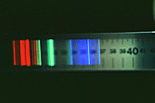 |  | The mercury spectrum is shown here.
Trustees of Dartmouth College, Copyright 1997–2001

