Experiment 19： Ammeter, Voltmeter, and Ohmmeter
I. Purpose：
Understanding the structure of the ammeter, voltmeter, and ohmmeter. Learning how to use those meters and using them to measure the current, voltage, and resistance of an electric circuit.
II. Principle：Major referred web site: http://www.allaboutcircuits.com/vol_1/chpt_8/1.html
A. What is a meter?
A meter is any device built to accurately detect and display an electrical quantity in a form readable by a human being. Usually this "readable form" is visual: motion of a pointer on a scale, a series of lights arranged to form a "bargraph," or some sort of display composed of numerical figures. In the analysis and testing of circuits, there are meters designed to accurately measure the basic quantities of voltage, current, and resistance. There are many other types of meters as well, but this experiment primarily covers the design and operation of the basic three.
Most modern meters are "digital" in design, meaning that their readable display is in the form of numerical digits. Older designs of meters are mechanical in nature, using some kind of pointer device to show quantity of measurement. In either case, the principles applied in adapting a display unit to the measurement of (relatively) large quantities of voltage, current, or resistance are the same.
The display mechanism of a meter is often referred to as a movement, borrowing from its mechanical nature to move a pointer along a scale so that a measured value may be read. Though modern digital meters have no moving parts, the term "movement" may be applied to the same basic device performing the display function.
The design of digital "movements" is beyond the scope of this chapter, but mechanical meter movement designs are very understandable. Most mechanical movements are based on the principle of electromagnetism: that electric current through a conductor produces a magnetic field perpendicular to the axis of electron flow. The greater the electric current, the stronger the magnetic field produced. If the magnetic field formed by the conductor is allowed to interact with another magnetic field, a physical force will be generated between the two sources of fields. If one of these sources is free to move with respect to the other, it will do so as current is conducted through the wire, the motion (usually against the resistance of a spring) being proportional to strength of current.
The first meter movements built were known as galvanometers, and were usually designed with maximum sensitivity in mind. A very simple galvanometer may be made from a magnetized needle (such as the needle from a magnetic compass) suspended from a string, and positioned within a coil of wire. Current through the wire coil will produce a magnetic field which will deflect the needle from pointing in the direction of earth's magnetic field. An antique string galvanometer is shown in the following photograph:
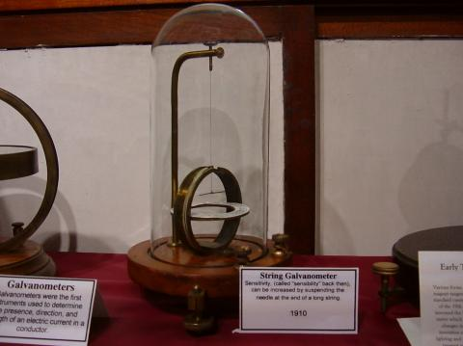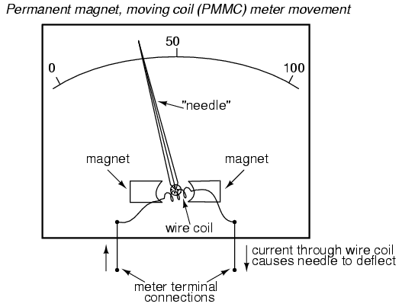
Fig. 1 (a) An antique string galvanometer, and (b) a permanent-magnet, moving coil, or PMMC movement.
Such instruments were useful in their time, but have little place in the modern world except as proof-of-concept and elementary experimental devices. They are highly susceptible to motion of any kind, and to any disturbances in the natural magnetic field of the earth. Now, the term "galvanometer" usually refers to any design of electromagnetic meter movement built for exceptional sensitivity, and not necessarily a crude device such as that shown in the photograph. Practical electromagnetic meter movements can be made now where a pivoting wire coil is suspended in a strong magnetic field, shielded from the majority of outside influences. Such an instrument design is generally known as a permanent-magnet, moving coil, or PMMC movement.
In the picture above, the meter movement "needle" is shown pointing somewhere around 35% of full-scale, zero being full to the left of the arc and full-scale being completely to the right of the arc. An increase in measured current will drive the needle to point further to the right and a decrease will cause the needle to drop back down toward its resting point on the left. The arc on the meter display is labeled with numbers to indicate the value of the quantity being measured, whatever that quantity is. In other words, if it takes 50µA of current to drive the needle fully to the right (making this a "50 µA full-scale movement"), the scale would have 0 µA written at the very left end and 50 µA at the very right, 25 µA being marked in the middle of the scale. In all likelihood, the scale would be divided into much smaller graduating marks, probably every 5 or 1 µA, to allow whoever is viewing the movement to infer a more precise reading from the needle's position.
The meter movement will have a pair of metal connection terminals on the back for current to enter and exit. Most meter movements are polarity-sensitive, one direction of current driving the needle to the right and the other driving it to the left. Some meter movements have a needle that is spring-centered in the middle of the scale sweep instead of to the left, thus enabling measurements of either polarity:
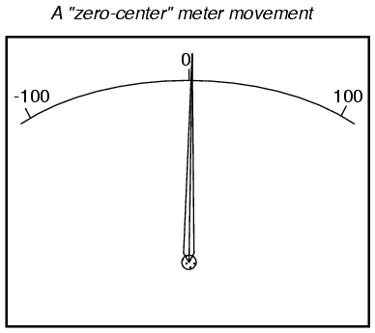
Common polarity-sensitive movements include the D'Arsonval and Weston designs, both PMMC-type instruments. Current in one direction through the wire will produce a clockwise torque on the needle mechanism, while current the other direction will produce a counter-clockwise torque.
Some meter movements are polarity-insensitive, relying on the attraction of an unmagnetized, movable iron vane toward a stationary, current-carrying wire to deflect the needle. Such meters are ideally suited for the measurement of alternating current (AC). A polarity-sensitive movement would just vibrate back and forth uselessly if connected to a source of AC.
While most mechanical meter movements are based on electromagnetism (electron flow through a conductor creating a perpendicular magnetic field), a few are based on electrostatics: that is, the attractive or repulsive force generated by electric charges across space. This is the same phenomenon exhibited by certain materials (such as wax and wool) when rubbed together. If a voltage is applied between two conductive surfaces across an air gap, there will be a physical force attracting the two surfaces together capable of moving some kind of indicating mechanism. That physical force is directly proportional to the voltage applied between the plates, and inversely proportional to the square of the distance between the plates. The force is also irrespective of polarity, making this a polarity-insensitive type of meter movement:
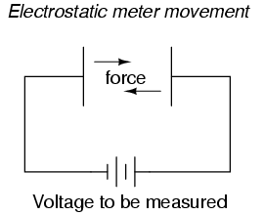
Unfortunately, the force generated by the electrostatic attraction is very small for common voltages. In fact, it is so small that such meter movement designs are impractical for use in general test instruments. Typically, electrostatic meter movements are used for measuring very high voltages (many thousands of volts). One great advantage of the electrostatic meter movement, however, is the fact that it has extremely high resistance, whereas electromagnetic movements (which depend on the flow of electrons through wire to generate a magnetic field) are much lower in resistance. As we will see in greater detail to come, greater resistance (resulting in less current drawn from the circuit under test) makes for a better voltmeter.
A much more common application of electrostatic voltage measurement is seen in an device known as a Cathode Ray Tube, or CRT. These are special glass tubes, very similar to television view screen tubes. In the cathode ray tube, a beam of electrons traveling in a vacuum are deflected from their course by voltage between pairs of metal plates on either side of the beam. Because electrons are negatively charged, they tend to be repelled by the negative plate and attracted to the positive plate. A reversal of voltage polarity across the two plates will result in a deflection of the electron beam in the opposite direction, making this type of meter "movement" polarity-sensitive:
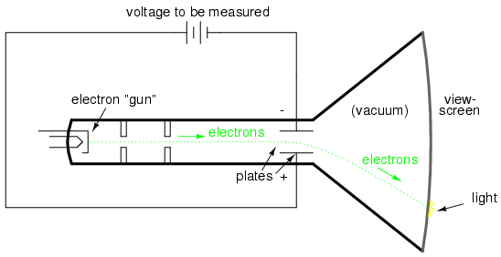

The electrons, having much less mass than metal plates, are moved by this electrostatic force very quickly and readily. Their deflected path can be traced as the electrons impinge on the glass end of the tube where they strike a coating of phosphorus chemical, emitting a glow of light seen outside of the tube. The greater the voltage between the deflection plates, the further the electron beam will be "bent" from its straight path, and the further the glowing spot will be seen from center on the end of the tube.
A photograph of a CRT is shown here:
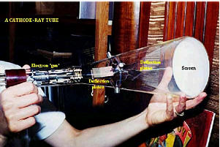
In a real CRT, as shown in the above photograph, there are two pairs of deflection plates rather than just one. In order to be able to sweep the electron beam around the whole area of the screen rather than just in a straight line, the beam must be deflected in more than one dimension.
Although these tubes are able to accurately register small voltages, they are bulky and require electrical power to operate (unlike electromagnetic meter movements, which are more compact and actuated by the power of the measured signal current going through them). They are also much more fragile than other types of electrical metering devices. Usually, cathode ray tubes are used in conjunction with precise external circuits to form a larger piece of test equipment known as an oscilloscope, which has the ability to display a graph of voltage over time, a tremendously useful tool for certain types of circuits where voltage and/or current levels are dynamically changing.
Whatever the type of meter or size of meter movement, there will be a rated value of voltage or current necessary to give full-scale indication. In electromagnetic movements, this will be the "full-scale deflection current" necessary to rotate the needle so that it points to the exact end of the indicating scale. In electrostatic movements, the full-scale rating will be expressed as the value of voltage resulting in the maximum deflection of the needle actuated by the plates, or the value of voltage in a cathode-ray tube which deflects the electron beam to the edge of the indicating screen. In digital "movements," it is the amount of voltage resulting in a "full-count" indication on the numerical display: when the digits cannot display a larger quantity.
The task of the meter designer is to take a given meter movement and design the necessary external circuitry for full-scale indication at some specified amount of voltage or current. Most meter movements (electrostatic movements excepted) are quite sensitive, giving full-scale indication at only a small fraction of a volt or an amp. This is impractical for most tasks of voltage and current measurement. What the technician often requires is a meter capable of measuring high voltages and currents.
By making the sensitive meter movement part of a voltage or current divider circuit, the movement's useful measurement range may be extended to measure far greater levels than what could be indicated by the movement alone. Precision resistors are used to create the divider circuits necessary to divide voltage or current appropriately. One of the lessons you will learn in this chapter is how to design these divider circuits.
REVIEW:
- A "movement" is the display mechanism of a meter.
- Electromagnetic movements work on the principle of a magnetic field being generated by electric current through a wire. Examples of electromagnetic meter movements include the D'Arsonval, Weston, and iron-vane designs.
- Electrostatic movements work on the principle of physical force generated by an electric field between two plates.

B. Voltmeter design
As was stated earlier, most meter movements are sensitive devices. Some D'Arsonval movements have full-scale deflection current ratings as little as 50 µA, with an (internal) wire resistance of less than 1000 Ω. This makes for a voltmeter with a full-scale rating of only 50 millivolts (50 µA X 1000 Ω)! In order to build voltmeters with practical (higher voltage) scales from such sensitive movements, we need to find some way to reduce the measured quantity of voltage down to a level the movement can handle.
Let's start our example problems with a D'Arsonval meter movement having a full-scale deflection rating of 1 mA and a coil resistance of 500 Ω:
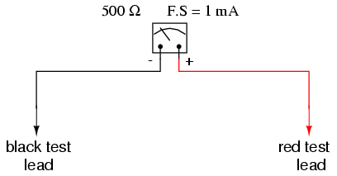
Using Ohm's Law (E=IR), we can determine how much voltage will drive this meter movement directly to full scale:
E = I R
E = (1 mA)(500 Ω) = 0.5 volts
If all we wanted was a meter that could measure 1/2 of a volt, the bare meter movement we have here would suffice. But to measure greater levels of voltage, something more is needed. To get an effective voltmeter meter range in excess of 1/2 volt, we'll need to design a circuit allowing only a precise proportion of measured voltage to drop across the meter movement. This will extend the meter movement's range to being able to measure higher voltages than before. Correspondingly, we will need to re-label the scale on the meter face to indicate its new measurement range with this proportioning circuit connected.
But how do we create the necessary proportioning circuit? Well, if our intention is to allow this meter movement to measure a greater voltage than it does now, what we need is a voltage divider circuit to proportion the total measured voltage into a lesser fraction across the meter movement's connection points. Knowing that voltage divider circuits are built from series resistances, we'll connect a resistor in series with the meter movement (using the movement's own internal resistance as the second resistance in the divider):
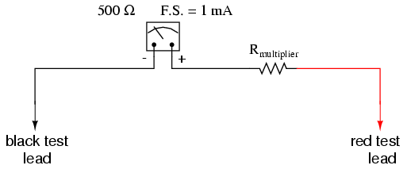
The series resistor is called a "multiplier" resistor because it multiplies the working range of the meter movement as it proportionately divides the measured voltage across it. Determining the required multiplier resistance value is an easy task if you're familiar with series circuit analysis.
For example, let's determine the necessary multiplier value to make this 1 mA, 500 Ω movement read exactly full-scale at an applied voltage of 10 volts. To do this, we first need to set up an E/I/R table for the two series components:
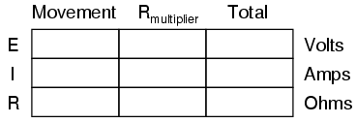
Knowing that the movement will be at full-scale with 1 mA of current going through it, and that we want this to happen at an applied (total series circuit) voltage of 10 volts, we can fill in the table as such:
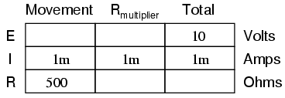
There are a couple of ways to determine the resistance value of the multiplier. One way is to determine total circuit resistance using Ohm's Law in the "total" column (R=E/I), then subtract the 500 Ω of the movement to arrive at the value for the multiplier:
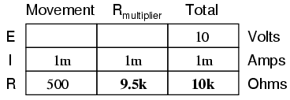
Another way to figure the same value of resistance would be to determine voltage drop across the movement at full-scale deflection (E=IR), then subtract that voltage drop from the total to arrive at the voltage across the multiplier resistor. Finally, Ohm's Law could be used again to determine resistance (R=E/I) for the multiplier:
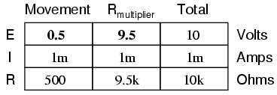
Either way provides the same answer (9.5 kΩ), and one method could be used as verification for the other, to check accuracy of work.
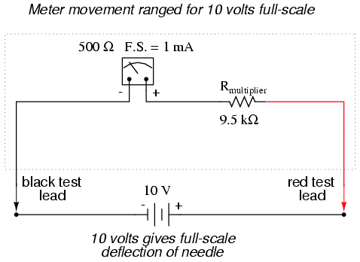
With exactly 10 volts applied between the meter test leads (from some battery or precision power supply), there will be exactly 1 mA of current through the meter movement, as restricted by the "multiplier" resistor and the movement's own internal resistance. Exactly 1/2 volt will be dropped across the resistance of the movement's wire coil, and the needle will be pointing precisely at full-scale. Having re-labeled the scale to read from 0 to 10 V (instead of 0 to 1 mA), anyone viewing the scale will interpret its indication as ten volts. Please take note that the meter user does not have to be aware at all that the movement itself is actually measuring just a fraction of that ten volts from the external source. All that matters to the user is that the circuit as a whole functions to accurately display the total, applied voltage.
This is how practical electrical meters are designed and used: a sensitive meter movement is built to operate with as little voltage and current as possible for maximum sensitivity, then it is "fooled" by some sort of divider circuit built of precision resistors so that it indicates full-scale when a much larger voltage or current is impressed on the circuit as a whole. We have examined the design of a simple voltmeter here. Ammeters follow the same general rule, except that parallel-connected "shunt" resistors are used to create a current divider circuit as opposed to the series-connected voltage divider "multiplier" resistors used for voltmeter designs.
Generally, it is useful to have multiple ranges established for an electromechanical meter such as this, allowing it to read a broad range of voltages with a single movement mechanism. This is accomplished through the use of a multi-pole switch and several multiplier resistors, each one sized for a particular voltage range:
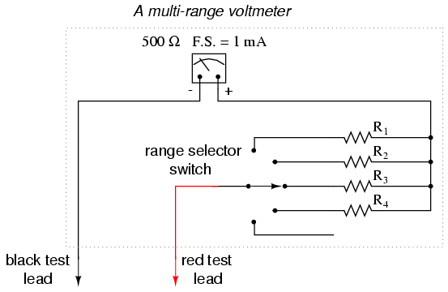
The five-position switch makes contact with only one resistor at a time. In the bottom (full clockwise) position, it makes contact with no resistor at all, providing an "off" setting. Each resistor is sized to provide a particular full-scale range for the voltmeter, all based on the particular rating of the meter movement (1 mA, 500 Ω). The end result is a voltmeter with four different full-scale ranges of measurement. Of course, in order to make this work sensibly, the meter movement's scale must be equipped with labels appropriate for each range.
With such a meter design, each resistor value is determined by the same technique, using a known total voltage, movement full-scale deflection rating, and movement resistance. For a voltmeter with ranges of 1 volt, 10 volts, 100 volts, and 1000 volts, the multiplier resistances would be as follows:
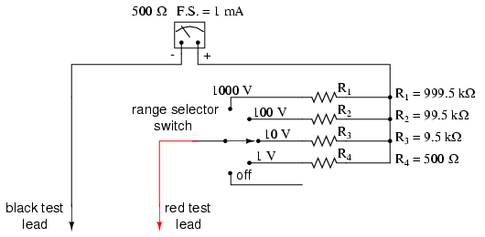
Note the multiplier resistor values used for these ranges, and how odd they are. It is highly unlikely that a 999.5 kΩ precision resistor will ever be found in a parts bin, so voltmeter designers often opt for a variation of the above design which uses more common resistor values:
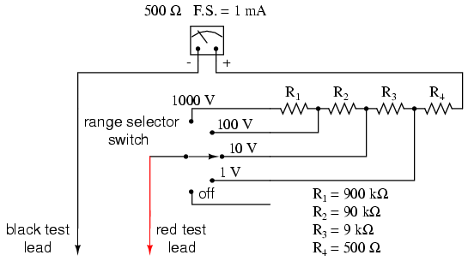
With each successively higher voltage range, more multiplier resistors are pressed into service by the selector switch, making their series resistances add for the necessary total. For example, with the range selector switch set to the 1000 volt position, we need a total multiplier resistance value of 999.5 kΩ. With this meter design, that's exactly what we'll get:
R_{Total} = R₄ + R₃ + R₂ + R₁
R_{Total} = 900 kΩ + 90 kΩ + 9 kΩ + 500 Ω = 999.5 kΩ
The advantage, of course, is that the individual multiplier resistor values are more common (900k, 90k, 9k) than some of the odd values in the first design (999.5k, 99.5k, 9.5k). From the perspective of the meter user, however, there will be no discernible difference in function.
- REVIEW:
- Extended voltmeter ranges are created for sensitive meter movements by adding series "multiplier" resistors to the movement circuit, providing a precise voltage division ratio.

C. Ammeter design
http://www.allaboutcircuits.com/vol_1/chpt_8/4.html
A meter designed to measure electrical current is popularly called an "ammeter" because the unit of measurement is "amps."
In ammeter designs, external resistors added to extend the usable range of the movement are connected in parallel with the movement rather than in series as is the case for voltmeters. This is because we want to divide the measured current, not the measured voltage, going to the movement, and because current divider circuits are always formed by parallel resistances.
Taking the same meter movement as the voltmeter example, we can see that it would make a very limited instrument by itself, full-scale deflection occurring at only 1 mA:
As is the case with extending a meter movement's voltage-measuring ability, we would have to correspondingly re-label the movement's scale so that it read differently for an extended current range. For example, if we wanted to design an ammeter to have a full-scale range of 5 amps using the same meter movement as before (having an intrinsic full-scale range of only 1 mA), we would have to re-label the movement's scale to read 0 A on the far left and 5 A on the far right, rather than 0 mA to 1 mA as before. Whatever extended range provided by the parallel-connected resistors, we would have to represent graphically on the meter movement face.
Using 5 amps as an extended range for our sample movement, let's determine the amount of parallel resistance necessary to "shunt," or bypass, the majority of current so that only 1 mA will go through the movement with a total current of 5 A:
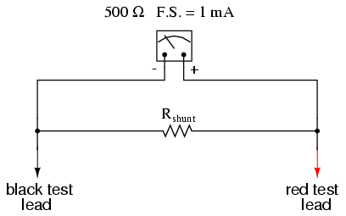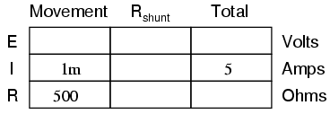
From our given values of movement current, movement resistance, and total circuit (measured) current, we can determine the voltage across the meter movement (Ohm's Law applied to the center column, E=IR):
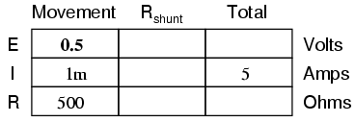
Knowing that the circuit formed by the movement and the shunt is of a parallel configuration, we know that the voltage across the movement, shunt, and test leads (total) must be the same:
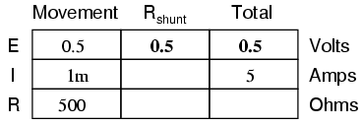
We also know that the current through the shunt must be the difference between the total current (5 amps) and the current through the movement (1 mA), because branch currents add in a parallel configuration:
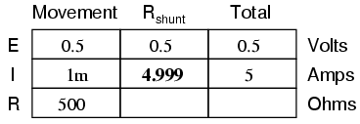
Then, using Ohm's Law (R=E/I) in the right column, we can determine the necessary shunt resistance:
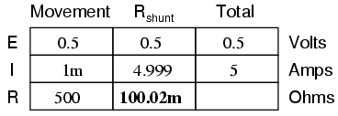
Of course, we could have calculated the same value of just over 100 milli-ohms (100 mΩ) for the shunt by calculating total resistance (R=E/I; 0.5 volts/5 amps = 100 mΩ exactly), then working the parallel resistance formula backwards, but the arithmetic would have been more challenging:
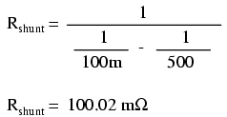
In real life, the shunt resistor of an ammeter will usually be encased within the protective metal housing of the meter unit, hidden from sight. Note the construction of the ammeter in the following photograph:
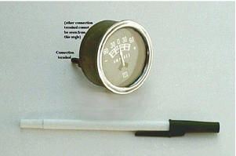
This particular ammeter is an automotive unit manufactured by Stewart-Warner. Although the D'Arsonval meter movement itself probably has a full scale rating in the range of milliamps, the meter as a whole has a range of +/- 60 amps. The shunt resistor providing this high current range is enclosed within the metal housing of the meter. Note also with this particular meter that the needle centers at zero amps and can indicate either a "positive" current or a "negative" current. Connected to the battery charging circuit of an automobile, this meter is able to indicate a charging condition (electrons flowing from generator to battery) or a discharging condition (electrons flowing from battery to the rest of the car's loads).
As is the case with multiple-range voltmeters, ammeters can be given more than one usable range by incorporating several shunt resistors switched with a multi-pole switch:
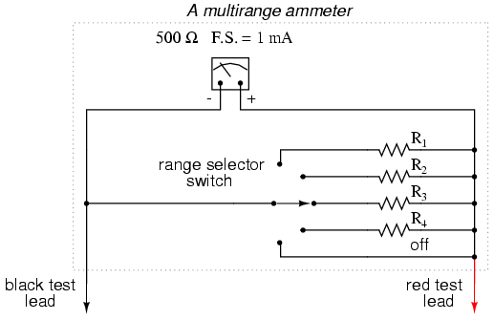
Notice that the range resistors are connected through the switch so as to be in parallel with the meter movement, rather than in series as it was in the voltmeter design. The five-position switch makes contact with only one resistor at a time, of course. Each resistor is sized accordingly for a different full-scale range, based on the particular rating of the meter movement (1 mA, 500 Ω).
With such a meter design, each resistor value is determined by the same technique, using a known total current, movement full-scale deflection rating, and movement resistance. For an ammeter with ranges of 100 mA, 1 A, 10 A, and 100 A, the shunt resistances would be as such:
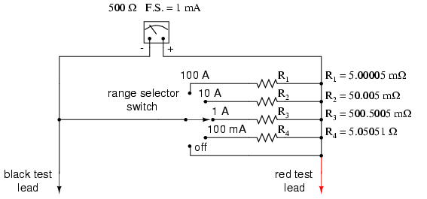
Notice that these shunt resistor values are very low! 5.00005 mΩ is 5.00005 milli-ohms, or 0.00500005 ohms! To achieve these low resistances, ammeter shunt resistors often have to be custom-made from relatively large-diameter wire or solid pieces of metal.
One thing to be aware of when sizing ammeter shunt resistors is the factor of power dissipation. Unlike the voltmeter, an ammeter's range resistors have to carry large amounts of current. If those shunt resistors are not sized accordingly, they may overheat and suffer damage, or at the very least lose accuracy due to overheating. For the example meter above, the power dissipations at full-scale indication are (the double-squiggly lines represent "approximately equal to" in mathematics):
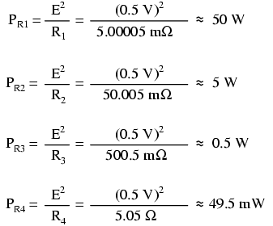
An 1/8 watt resistor would work just fine for R₄, a 1/2 watt resistor would suffice for R₃ and a 5 watt for R₂ (although resistors tend to maintain their long-term accuracy better if not operated near their rated power dissipation, so you might want to over-rate resistors R₂ and R₃), but precision 50 watt resistors are rare and expensive components indeed. A custom resistor made from metal stock or thick wire may have to be constructed for R₁ to meet both the requirements of low resistance and high power rating.
Sometimes, shunt resistors are used in conjunction with voltmeters of high input resistance to measure current. In these cases, the current through the voltmeter movement is small enough to be considered negligible, and the shunt resistance can be sized according to how many volts or millivolts of drop will be produced per amp of current:
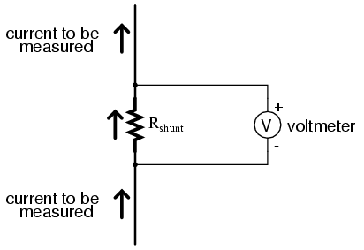
If, for example, the shunt resistor in the above circuit were sized at precisely 1 Ω, there would be 1 volt dropped across it for every amp of current through it. The voltmeter indication could then be taken as a direct indication of current through the shunt. For measuring very small currents, higher values of shunt resistance could be used to generate more voltage drop per given unit of current, thus extending the usable range of the (volt)meter down into lower amounts of current. The use of voltmeters in conjunction with low-value shunt resistances for the measurement of current is something commonly seen in industrial applications.
The use of a shunt resistor along with a voltmeter to measure current can be a useful trick for simplifying the task of frequent current measurements in a circuit. Normally, to measure current through a circuit with an ammeter, the circuit would have to be broken (interrupted) and the ammeter inserted between the separated wire ends, like this:
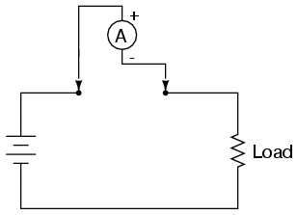
If we have a circuit where current needs to be measured often, or we would just like to make the process of current measurement more convenient, a shunt resistor could be placed between those points and left their permanently, current readings taken with a voltmeter as needed without interrupting continuity in the circuit:
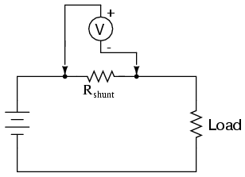
Of course, care must be taken in sizing the shunt resistor low enough so that it doesn't adversely affect the circuit's normal operation, but this is generally not difficult to do. This technique might also be useful in computer circuit analysis, where we might want to have the computer display current through a circuit in terms of a voltage (with SPICE, this would allow us to avoid the idiosyncrasy of reading negative current values):
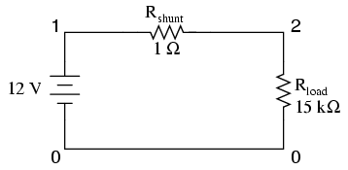

shunt resistor example circuit
v1 1 0
rshunt 1 2 1
rload 2 0 15k
.dc v1 12 12 1
.print dc v(1,2)
.end

v1 v(1,2)
1.200E+01 7.999E-04

We would interpret the voltage reading across the shunt resistor (between circuit nodes 1 and 2 in the SPICE simulation) directly as amps, with 7.999E-04 being 0.7999 mA, or 799.9 µA. Ideally, 12 volts applied directly across 15 kΩ would give us exactly 0.8 mA, but the resistance of the shunt lessens that current just a tiny bit (as it would in real life). However, such a tiny error is generally well within acceptable limits of accuracy for either a simulation or a real circuit, and so shunt resistors can be used in all but the most demanding applications for accurate current measurement.
REVIEW:
- Ammeter ranges are created by adding parallel "shunt" resistors to the movement circuit, providing a precise current division.
- Shunt resistors may have high power dissipations, so be careful when choosing parts for such meters!
- Shunt resistors can be used in conjunction with high-resistance voltmeters as well as low-resistance ammeter movements, producing accurate voltage drops for given amounts of current. Shunt resistors should be selected for as low a resistance value as possible to minimize their impact upon the circuit under test.

D. Ohmmeter design
Though mechanical ohmmeter (resistance meter) designs are rarely used today, having largely been superseded by digital instruments, their operation is nonetheless intriguing and worthy of study.
The purpose of an ohmmeter, of course, is to measure the resistance placed between its leads. This resistance reading is indicated through a mechanical meter movement which operates on electric current. The ohmmeter must then have an internal source of voltage to create the necessary current to operate the movement, and also have appropriate ranging resistors to allow just the right amount of current through the movement at any given resistance.
Starting with a simple movement and battery circuit, let's see how it would function as an ohmmeter:
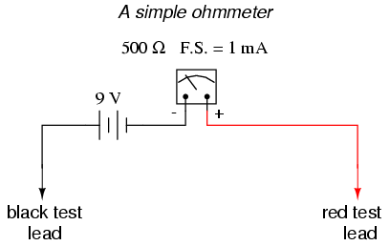
When there is infinite resistance (no continuity between test leads), there is zero current through the meter movement, and the needle points toward the far left of the scale. In this regard, the ohmmeter indication is "backwards" because maximum indication (infinity) is on the left of the scale, while voltage and current meters have zero at the left of their scales.
If the test leads of this ohmmeter are directly shorted together (measuring zero Ω), the meter movement will have a maximum amount of current through it, limited only by the battery voltage and the movement's internal resistance:
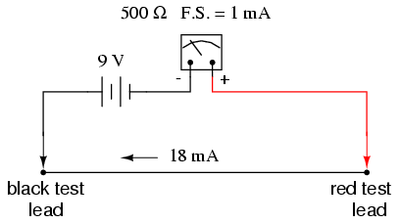
With 9 volts of battery potential and only 500 Ω of movement resistance, our circuit current will be 18 mA, which is far beyond the full-scale rating of the movement. Such an excess of current will likely damage the meter.
Not only that, but having such a condition limits the usefulness of the device. If full left-of-scale on the meter face represents an infinite amount of resistance, then full right-of-scale should represent zero. Currently, our design "pegs" the meter movement hard to the right when zero resistance is attached between the leads. We need a way to make it so that the movement just registers full-scale when the test leads are shorted together. This is accomplished by adding a series resistance to the meter's circuit:
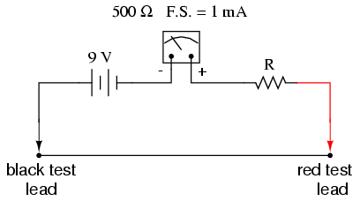
To determine the proper value for R, we calculate the total circuit resistance needed to limit current to 1 mA (full-scale deflection on the movement) with 9 volts of potential from the battery, then subtract the movement's internal resistance from that figure:
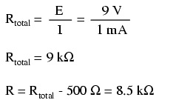
Now that the right value for R has been calculated, we're still left with a problem of meter range. On the left side of the scale we have "infinity" and on the right side we have zero. Besides being "backwards" from the scales of voltmeters and ammeters, this scale is strange because it goes from nothing to everything, rather than from nothing to a finite value (such as 10 volts, 1 amp, etc.). One might pause to wonder, "what does middle-of-scale represent? What figure lies exactly between zero and infinity?" Infinity is more than just a very big amount: it is an incalculable quantity, larger than any definite number ever could be. If half-scale indication on any other type of meter represents 1/2 of the full-scale range value, then what is half of infinity on an ohmmeter scale?
The answer to this paradox is a logarithmic scale. Simply put, the scale of an ohmmeter does not smoothly progress from zero to infinity as the needle sweeps from right to left. Rather, the scale starts out "expanded" at the right-hand side, with the successive resistance values growing closer and closer to each other toward the left side of the scale:
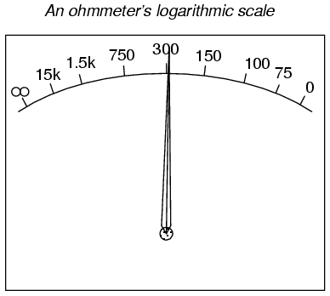
Infinity cannot be approached in a linear (even) fashion, because the scale would never get there! With a logarithmic scale, the amount of resistance spanned for any given distance on the scale increases as the scale progresses toward infinity, making infinity an attainable goal.
We still have a question of range for our ohmmeter, though. What value of resistance between the test leads will cause exactly 1/2 scale deflection of the needle? If we know that the movement has a full-scale rating of 1 mA, then 0.5 mA (500 µA) must be the value needed for half-scale deflection. Following our design with the 9 volt battery as a source we get:
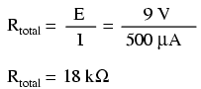
With an internal movement resistance of 500 Ω and a series range resistor of 8.5 kΩ, this leaves 9 kΩ for an external (lead-to-lead) test resistance at 1/2 scale. In other words, the test resistance giving 1/2 scale deflection in an ohmmeter is equal in value to the (internal) series total resistance of the meter circuit.
Using Ohm's Law a few more times, we can determine the test resistance value for 1/4 and 3/4 scale deflection as well:

1/4 scale deflection (0.25 mA of meter current):
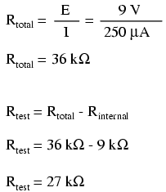
3/4 scale deflection (0.75 mA of meter current):
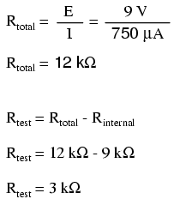
So, the scale for this ohmmeter looks something like this:
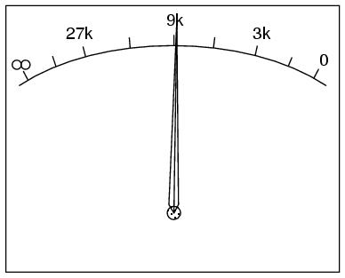
One major problem with this design is its reliance upon a stable battery voltage for accurate resistance reading. If the battery voltage decreases (as all chemical batteries do with age and use), the ohmmeter scale will lose accuracy. With the series range resistor at a constant value of 8.5 kΩ and the battery voltage decreasing, the meter will no longer deflect full-scale to the right when the test leads are shorted together (0 Ω). Likewise, a test resistance of 9 kΩ will fail to deflect the needle to exactly 1/2 scale with a lesser battery voltage.
There are design techniques used to compensate for varying battery voltage, but they do not completely take care of the problem and are to be considered approximations at best. For this reason, and for the fact of the logarithmic scale, this type of ohmmeter is never considered to be a precision instrument.
One final caveat needs to be mentioned with regard to ohmmeters: they only function correctly when measuring resistance that is not being powered by a voltage or current source. In other words, you cannot measure resistance with an ohmmeter on a "live" circuit! The reason for this is simple: the ohmmeter's accurate indication depends on the only source of voltage being its internal battery. The presence of any voltage across the component to be measured will interfere with the ohmmeter's operation. If the voltage is large enough, it may even damage the ohmmeter.
REVIEW:
- Ohmmeters contain internal sources of voltage to supply power in taking resistance measurements.
- An analog ohmmeter scale is "backwards" from that of a voltmeter or ammeter, the movement needle reading zero resistance at full-scale and infinite resistance at rest.
- Analog ohmmeters also have logarithmic scales, "expanded" at the low end of the scale and "compressed" at the high end to be able to span from zero to infinite resistance.
- Analog ohmmeters are not precision instruments.
- Ohmmeters should never be connected to an energized circuit (that is, a circuit with its own source of voltage). Any voltage applied to the test leads of an ohmmeter will invalidate its reading.

III. Apparatus：
A Galvanometer, a low-voltage dc power supply, a multifunction meter (multimeter) and a bread board.
Some resistors: 1 Ω (Rp), 10 Ω, 150 Ω (1 W), 300 Ω (1 W), 390 Ω, 39 kΩ (R_{so}), 50 kΩ (R), 100 kΩ (R), 200 kΩ (R_{s}), and 390 kΩ.

IV. Experimental Steps:
Caution: In this experiment, one must be avoid damage the galvanometer due to use incorrect resistors. One must make sure the resistance values of the used resistors by reading the colored code which display on the resistor (See appendix A) as well as by measuring the actual resistance value by a multifunction meter. To make sure the magnitudes of the resistance of the resistors you use.
- Ammeter:
- Designing an ammeter that can measure the maximum current up to 50 mA by using a galvanometer (compute the appropriate magnitude of the resistance R_{p}, and find such a resistance and install it.). Note, the internal resistance R_{c} of the galvanometer would shows on the casing. Don’t use the multimeter to measure the internal resistance.
- Series connect the ammeter with the electric circuit shows in Fig. 1. Turn on the DC power supply up to 5V, and read the magnitude of the current. Note, setting the output knob in the minimum value before turning on the power supply.
Fig. 1. Measuring the current by an ammeter.

- Substituting your ammeter by a multimeter to measure the current. Compare the result of those two meters.
- Now, change the resistance R_{p} and makes the ammeter can measure the maximum current up to 5 mA. Substitute the 150Ω resistance shows in Fig. 6 by a 300Ω resistance. Turn the output voltage of the DC power supply up to 1V, repeat step 1~3.
(2) Voltmeter
- Designing a voltmeter that can measure the voltage up to 10V by a galvanometer. Use the formula 4 to compute the appropriate resistance R_{s} and find such a resistance. Install the voltmeter as shows in Fig. 2(a).
- Parallel connect the voltmeter with the electric circuit shows in Fig. 2(b). Turn on the DC power supply in the range 5~8V, and read the magnitude of the voltage.
- Substituting your voltmeter by a multimeter to measure the voltage. Compare the result of those two meters.
- Change the resistance R_{s} and makes the voltmeter can measure the maximum voltage up to 2.5 V. Change the output voltage of the DC power supply in a new range 1.5~2V, repeat step 1~3.
Fig. 2 (a) Circuit diagram of a voltmeter. (b) Circuit diagram for voltage measurement.
  - Ohmmeter
The value of ε = 2 V is given by the dc power supply and calculate the resistance R_{so} according to the following equation. The galvanometer is designed into an ohmmeter as show in Fig. 3.
$$I_{c}(=\text{50}μA)=\frac{ε}{R_{c}+R_{\text{so}}}$$
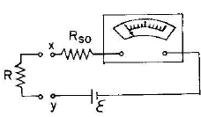
Fig. 3 Circuit diagram of a ohmmeter.

- Measure the resistance(~39kΩ) by the ohmmeter.
- Measure the resistance by a multimeter, compare the results of those tow meters.
- When using your ohmmeter to measure the resistance 300 kΩ or 390 kΩ, how accurate the ohmmeter can be?

IV.：Questions
- In Fig. 1, measure the current pass through the 150Ω resistance by your ammeter. Compare the voltage different of the ammeter and the resistance.
- In Fig. 2(a), measure the voltage different of the 150Ω resistance by your voltmeter. And what is the current pass through your voltmeter?
- As shown in Fig 4, combine a galvanometer and three resistances R₁, R₂, and R₃ to become a multi-range ammeter with range 1 A, 0.1 A and 0.01 A. What is the magnitude of those resistances should be use?
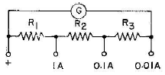
Fig. 4 The configuration of the internal resistors in a multi-range ammeter.

- The structure of multi-range voltmeter is shows in Fig. 5. To satisfy the range 2.5V, 10V, and 50V, what is the magnitude of the resistances R₁, R₂, and R₃ should be?
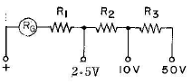
Fig. 5. The configuration of the internal resistors in a multi-range voltmeter.
- Why can’t remain the multimeter in the mode of measuring the resistance when we finish use of it (Ref. 2,3)?
- How large the resistance different between the color ring and the multi-meter (estimate the deviation of our experiment by the statistical deviation analysis introduce in Experiment 1.)?

Reference:
- Chapters related to electric circuit, in most textbooks of “General Physics”.
- Chapter 8 in the web site of “All about circuits”, http://www.allaboutcircuits.com/vol_1/chpt_8/1.html

