Lab. 3 Rotational Motion

Most fundamental concepts are substracted from the web site: http://hyperphysics.phy-astr.gsu.edu/hbase/hframe.html



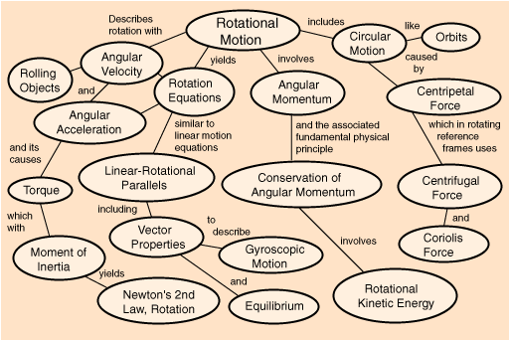

Circular Motion

http://hyperphysics.phy-astr.gsu.edu/hbase/circ.html#rotcon
For circular motion at a constant speed v, the centripetal acceleration of the motion can be derived. Since in radian measure,

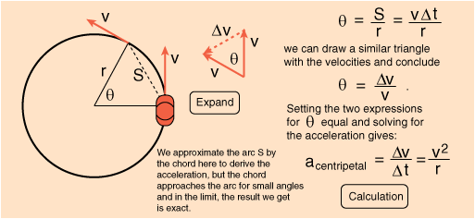

Basic Rotational Quantities
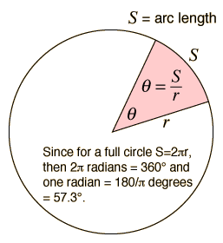  In addition to any tangential acceleration, there is always the centripetal acceleration:  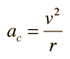 | The angular displancment is defined by:  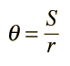  For a circular path it follows that the angular velocity is  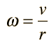  and the angular acceleration is  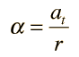  where the acceleration here is the tangential acceleration.

The standard angle of a directed quantity is taken to be counterclockwise from the positive x axis.

Torque

http://hyperphysics.phy-astr.gsu.edu/hbase/torq.html#torq
A torque is an influence which tends to change the rotational motion of an object. One way to quantify a torque is

Torque = Force applied x lever arm
The lever arm is defined as the perpendicular distance from the axis of rotation to the line of action of the force.

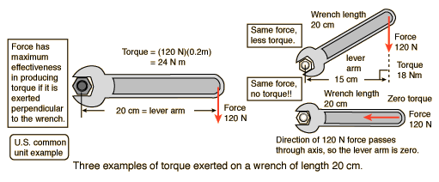

Right Hand Rule for Torque
Torque is inherently a vector quantity. Part of the torque calculation is the determination of direction. The direction is perpendicular to both the radius from the axis and to the force. It is conventional to choose it in the right hand rule direction along the axis of rotation. The torque is in the direction of the angular velocity which would be produced by it in the absence of other influences. In general, the change in angular velocity is in the direction of the torque.

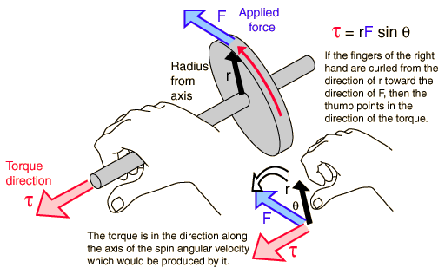

Newton's Second Law
Newton's Second Law as stated below applies to a wide range of physical phenomena, but it is not a fundamental principle like the Conservation Laws. It is applicable only if the force is the net external force. It does not apply directly to situations where the mass is changing, either from loss or gain of material, or because the object is traveling close to the speed of light where relativistic effects must be included. It does not apply directly on the very small scale of the atom where quantum mechanics must be used.
Data can be entered into any of the boxes below. Specifying any two of the quantities determines the third. After you have entered values for two, click on the text representing to third to calculate its value.

Newtons = kg * m/s²
pounds = slugs * ft/s²
Limitations of Newton's Second Law

Newton's Second Law Illustration
Newton's 2nd Law enables us to compare the results of the same force exerted on objects of different mass.
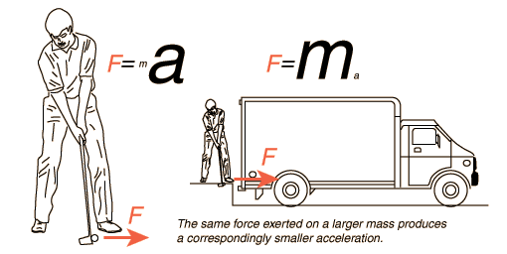

Limitations on Newton's 2nd Law
One of the best known relationships in physics is Newton's 2nd Law
but, though extremely useful, it is not a fundamental principle like the conservation laws. F must be the net external force, and even then a more fundamental relationship is



The net force should be defined as the rate of change of momentum; this becomes
only if the mass is constant. Since the mass changes as the speed approaches the speed of light, F=ma is seen to be strictly a non-relativistic relationship which applies to the acceleration of constant mass objects. Despite these limitations, it is extremely useful for the prediction of motion under these constraints.

Variable Mass Applications
The generalization of Newton's 2nd Law to apply to variable mass systems takes the form
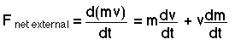
The term involving the derivative of the mass is responsible for the thrust in rocket propulsion and must be included in any problem where the mass changes.

Newton's 2nd Law: Rotation

http://hyperphysics.phy-astr.gsu.edu/hbase/hframe.html
The relationship between the net external torque and the angular acceleration is of the same form as Newton's second law and is sometimes called Newton's second law for rotation. It is not as general a relationship as the linear one because the moment of inertia is not strictly a scalar quantity. The rotational equation is limited to rotation about a single principal axis, which in simple cases is an axis of symmetry.
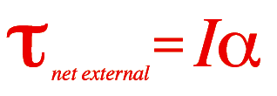

Net external torque = moment of inertia x angular acceleration
N m = kg m² x rad/s²
N m = kg m² x rad/s²

You may enter data for any two of the quantities and then click on the active text for the quantity you wish to calculate. The data values will not be forced to be consistent until you click on the quantity to calculate.

Conditions for Equilibrium
An object at equilibrium has no net influences to cause it to move, either in translation (linear motion) or rotation. The basic conditions for equilibrium are:
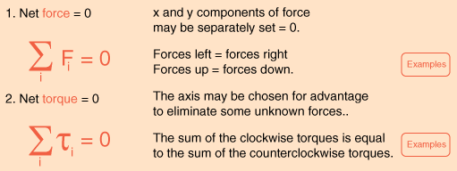
The conditions for equilibrium are basic to the design of any load-bearing structure such as a bridge or a building since such structures must be able to maintain equilibrium under load. They are also important for the study of machines, since one must first establish equilibrium and then apply extra force or torque to produce the desired movement of the machine. The conditions of equilibrium are used to analyze the "simple machines" which are the building blocks for more complex machines.

Moment of Inertia
Moment of inertia is the name given to rotational inertia, the rotational analog of mass for linear motion. It appears in the relationships for the dynamics of rotational motion. The moment of inertia must be specified with respect to a chosen axis of rotation. For a point mass the moment of inertia is just the mass times the square of perpendicular distance to the rotation axis, I = mr². That point mass relationship becomes the basis for all other moments of inertia since any object can be built up from a collection of point masses.

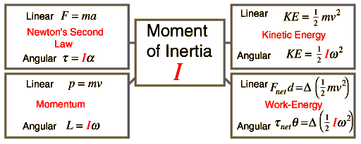

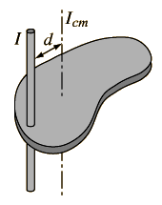
Parallel Axis Theorem

http://hyperphysics.phy-astr.gsu.edu/hbase/parax.html
The moment of inertia of any object about an axis through its center of mass is the minimum moment of inertia for an axis in that direction in space. The moment of inertia about any axis parallel to that axis through the center of mass is given by

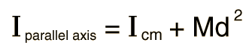

Perpendicular Axis Theorem
For a planar object, the moment of inertia about an axis perpendicular to the plane is the sum of the moments of inertia of two perpendicular axes through the same point in the plane of the object. The utility of this theorem goes beyond that of calculating moments of strictly planar objects. It is a valuable tool in the building up of the moments of inertia of three dimensional objects such as cylinders by breaking them up into planar disks and summing the moments of inertia of the composite disks.
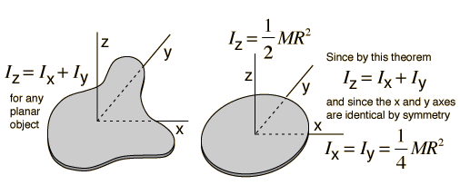

Show the development of the relationship.

Perpendicular Axis Theorem
The perpendicular axis theorem for planar objects can be demonstrated by looking at the contribution to the three axis moments of inertia from an arbitrary mass element. From the point mass moment, the contributions to each of the axis moments of inertia are
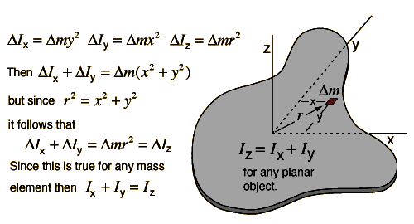

Rotational and Linear Example
A mass m is placed on a rod of length r and negligible mass, and constrained to rotate about a fixed axis. If the mass is released from a horizontal orientation, it can be described either in terms of force and accleration with Newton's second law for linear motion, or as a pure rotation about the axis with Newton's second law for rotation. This provides a setting for comparing linear and rotational quantities for the same system. This process leads to the expression for the moment of inertia of a point mass.
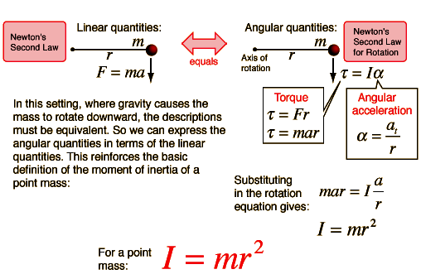

Moment of Inertia: Rod
For a uniform rod with negligible thickness, the moment of inertia about its center of mass is

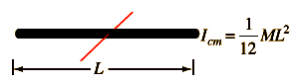
  For mass M = kg and length
  L = m, the moment of inertia is
  I = kg m² Show
The moment of inertia about the end of the rod can be calculated directly or obtained from the center of mass expression by use of the Parallel axis theorem.
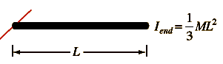
  The moment of inertia about the end of the rod is
  I = kg m². Show
If the thickness is not negligible, then the expression for I of a cylinder about its end can be used.

Moment of Inertia: Rod
Calculating the moment of inertia of a rod about its center of mass is a good example of the need for calculus to deal with the properties of continuous mass distributions. The moment of inertia of a point mass is given by I = mr², but the rod would have to be considered to be an infinite number of point masses, and each must be multiplied by the square of its distance from the axis. The resulting infinite sum is called an integral. The general form for the moment of inertia is:
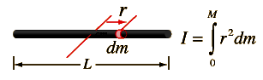
When the mass element dm is expressed in terms of a length element dr along the rod and the sum taken over the entire length, the integral takes the form:
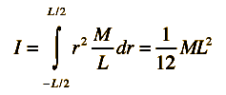
  Show details

Rod Moment Calculation
The moment of inertia calculation for a uniform rod involves expressing any mass element in terms of a distance element dr along the rod. To perform the integral, it is necessary to express eveything in the integral in terms of one variable, in this case the length variable r. Since the total length L has mass M, then M/L is the proportion of mass to length and the mass element can be expressed as shown. Integrating from -L/2 to +L/2 from the center includes the entire rod. The integral is of polynomial type: | 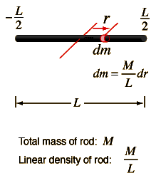
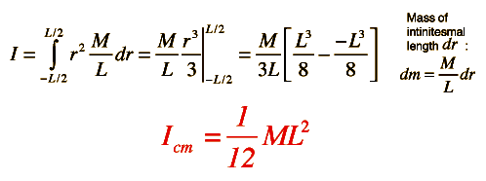

Rod Moment About End
Once the moment of inertia of an object about its center of mass has been determined, the moment about any other axis can be determined by the Parallel axis theorem: | 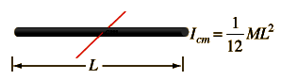
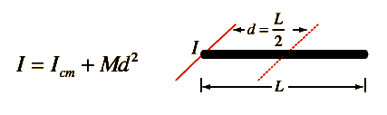
In this case that becomes
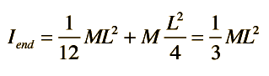
This can be confirmed by direct integration
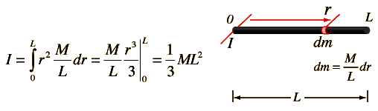

Rotational-Linear Parallels

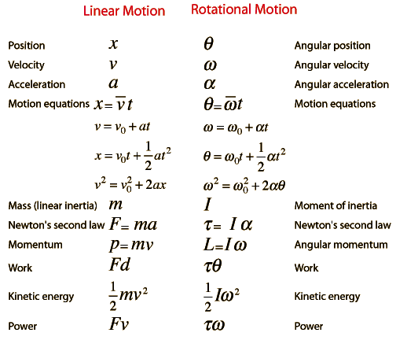

Common Moments of Inertia
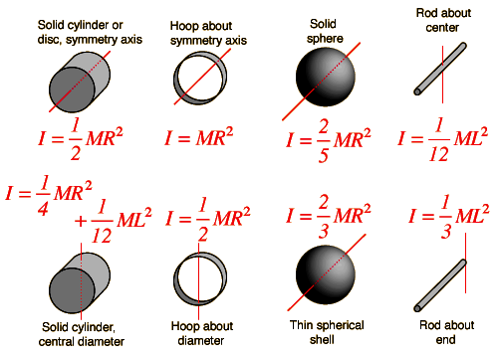

Moment of Inertia Examples
Moment of inertia is defined with respect to a specific rotation axis. The moment of inertia of a point mass with respect to an axis is defined as the product of the mass times the distance from the axis squared. The moment of inertia of any extended object is built up from that basic definition. The general form of the moment of inertia involves an integral.
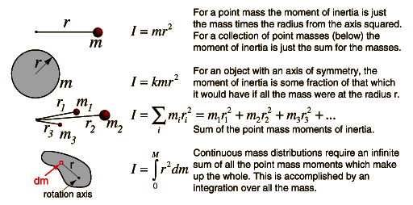
Moments of inertia for common forms

Where moment of inertia appears in physical quantities

Moment of Inertia, General Form
Since the moment of inertia of an ordinary object involves a continuous distribution of mass at a continually varying distance from any rotation axis, the calculation of moments of inertia generally involves calculus, the discipline of mathematics which can handle such continuous variables. Since the moment of inertia of a point mass is defined by
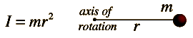
then the moment of inertia contribution by an infinitesmal mass element dm has the same form. This kind of mass element is called a differential element of mass and its moment of inertia is given by
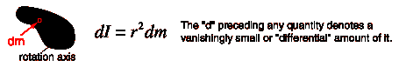
Note that the differential element of moment of inertia dI must always be defined with respect to a specific rotation axis. The sum over all these mass elements is called an integral over the mass.
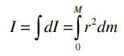
Usually, the mass element dm will be expressed in terms of the geometry of the object, so that the integration can be carried out over the object as a whole (for example, over a long uniform rod).
Having called this a general form, it is probably appropriate to point out that it is a general form only for axes which may be called "principal axes", a term which includes all axes of symmetry of objects. The concept of moment of inertia for general objects about arbitrary axes is a much more complicated subject. The moment of inertia in such cases takes the form of a mathematical tensor quantity which requires nine components to completely define it.
Examples of integration to get moment of inertia. | Straight rod
Examples of integration to get moment of inertia. | Cylinder
Examples of integration to get moment of inertia. | Sphere

Parallel axis theorem

http://en.wikipedia.org/wiki/Parallel_axis_theorem, From Wikipedia, the free encyclopedia
In physics, the parallel axis theorem can be used to determine the moment of inertia of a rigid object about any axis, given the moment of inertia of the object about the parallel axis through the object's centre of mass and the perpendicular distance between the axes.
Let:
I_{CM} denote the moment of inertia of the object about the centre of mass,
M the object's mass and d the perpendicular distance between the two axes.
Then the moment of inertia about the new axis z is given by:
This rule can be applied with the stretch rule and perpendicular axes rule to find moments of inertia for a variety of shapes.

Parallel axes rule for area moment of inertia.
The parallel axes rule also applies to the second moment of area (area moment of inertia);
where:
I_{z} is the area moment of inertia through the parallel axis,
I_{x} is the area moment of inertia through the centre of mass of the area,
A is the surface of the area, and
d is the distance from the new axis z to the centre of gravity of the area.
The parallel axis theorem is one of several theorems referred to as Steiner's theorem, after Jakob Steiner.

In classical mechanics
In classical mechanics, the Parallel axis theorem can be generalized to calculate a new inertia tensor J_{ij} from an inertia tensor about a center of mass I_{ij} when the pivot point is a displacement a from the center of mass:
J_{ij} = I_{ij} + M(a²δ_{ij} − a_{i}a_{j})
Where a is the displacement vector from the center of mass to the new axis.
We can see that, for diagonal elements (when i=j), displacements perpendicular to the axis of rotation results in the above simplified version of the parallel axis theorem.

Angular Momentum of a Particle
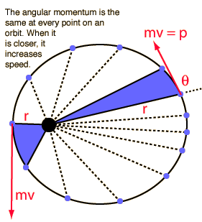 | The angular momentum of a particle of mass m with respect to a chosen origin is given by  L = mvr sin θ  or more formally by the vector product  L = r x p  The direction is given by the right hand rule which would give L the direction out of the diagram. For an orbit, angular momentum is conserved, and this leads to one of Kepler's laws. For a circular orbit, L becomes  L = mvr

Angular Momentum
The angular momentum of a rigid object is defined as the product of the moment of inertia and the angular velocity. It is analogous to linear momentum and is subject to the fundamental constraints of the conservation of angular momentum principle if there is no external torque on the object. Angular momentum is a vector quantity. It is derivable from the expression for the angular momentum of a particle
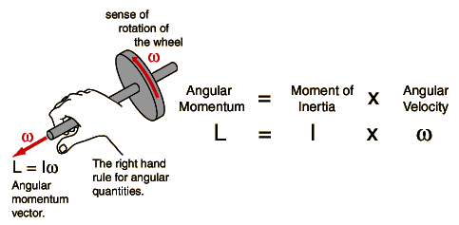
Comparison of linear and angular momentum

Angular and Linear Momentum
Angular momentum and linear momentum are examples of the parallels between linear and rotational motion. They have the same form and are subject to the fundamental constraints of conservation laws, the conservation of momentum and the conservation of angular momentum .
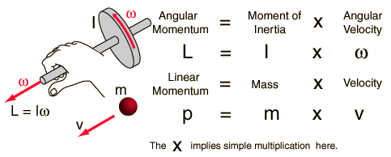

Rotational Kinetic Energy
The kinetic energy of a rotating object is analogous to linear kinetic energy and can be expressed in terms of the moment of inertia and angular velocity. The total kinetic energy of an extended object can be expressed as the sum of the translational kinetic energy of the center of mass and the rotational kinetic energy about the center of mass. For a given fixed axis of rotation, the rotational kinetic energy can be expressed in the form:
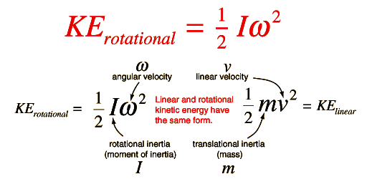
The expressions for rotational and linear kinetic energy can be developed in a parallel manner from the work-energy principle. Consider the following parallel between a constant torque exerted on a flywheel with moment of inertia I and a constant force exerted on a mass m, both starting from rest.
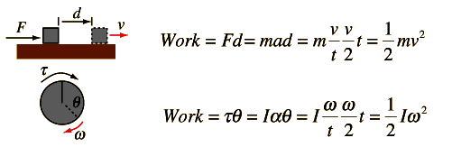
For the linear case, starting from rest, the acceleration from Newton's second law is equal to the final velocity divided by the time and the average velocity is half the final velocity, showing that the work done on the block gives it a kinetic energy equal to the work done. For the rotational case, also starting from rest, the rotational work is τθ and the angular acceleration α given to the flywheel is obtained from Newton's second law for rotation. The angular acceleration is equal to the final angular velocity divided by the time and the average angular velocity is equal to half the final angular velocity. It follows that the rotational kinetic energy given to the flywheel is equal to the work done by the torque.

Work-Energy Principle
The work-energy principle is a general principle which can be applied specifically to rotating objects. For pure rotation, the net work is equal to the change in rotational kinetic energy:
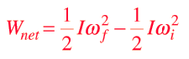
For a constant torque, the work can be expressed as
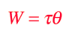
and for a net torque, Newton's 2nd law for rotation gives

Combining this last expression with the work-energy principle gives a useful relationship for describing rotational motion.
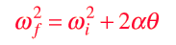
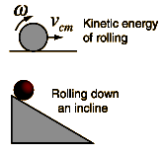
Rolling Objects
In describing the motion of rolling objects, it must be kept in mind that the kinetic energy is divided between linear kinetic energy and rotational kinetic energy. Another key is that for rolling without slipping, the linear velocity of the center of mass is equal to the angular velocity times the radius.

Sphere on incline. & Hoop and cylinder on incline.

Kinetic Energy of Rolling Object
If an object is rolling without slipping, then its kinetic energy can be expressed as the sum of the translational kinetic energy of its center of mass plus the rotational kinetic energy about the center of mass. The angular velocity is of course related to the linear velocity of the center of mass, so the energy can be expressed in terms of either of them as the problem dictates, such as in the rolling of an object down an incline. Note that the moment of inertia used must be the moment of inertia about the center of mass. If it is known about some other axis, then the parallel axis theorem may be used to obtain the needed moment of inertia.
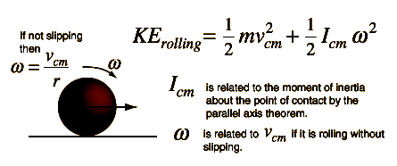

Rotation Vector Examples

http://hyperphysics.phy-astr.gsu.edu/hbase/hframe.html, This is an active graphic. Click on any example.
