Abstract—A short summary of the work can go here. What is your motivation? Provide some background information. What have you done or learned in this report? Chinese or English is equally okay with me.
Author Name in Chinese & Student ID number
Your Department or Institute
Title of Your Term Paper

INTRODUCTION and BACKGROUND
THIS document is a one-page template derived from the standard IEEE style template for papers and transactions (http://www.ieee.org/web/publications/authors/transjnl/index.html). The template is for Microsoft Word.
This report is like a literature review¹. First, you focus on some topic that interested you.
Introduction and background information go here.
Your motivation goes here.
The report should be as short as possible. The best size is 4 pages and do not longer than 6 pages.

Principle and Derivation of Equation
This section describes the working principle. You can derivate the equation(s) here. The equation(s) should be type with Equation Editor or MathType.

Experimental Setup
Detail the experimental setup if applicable.

RESULTS
Figures: Format and save your graphic images using a suitable graphics processing program that will allow you to save the images as a jpeg file, for example, and then insert the figure inline with the text using the Insert→Picture→ From-File menu.
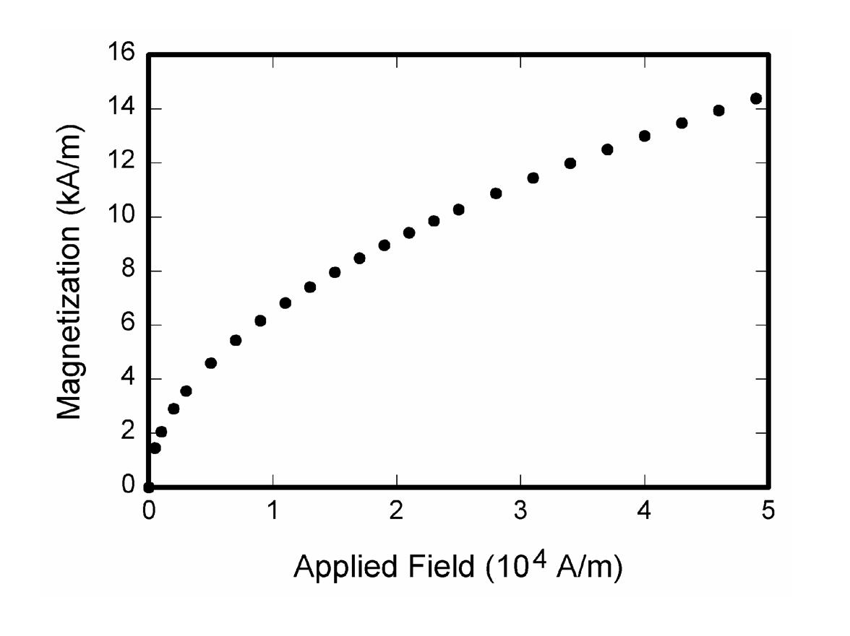
The total number of the figures should be less than 8. You need to give a caption to each figure.

Discussions
You can discuss what you have found or learned here. You can compare your finding with previous results
References
- G. O. Young, “Synthetic structure of industrial plastics (Book style with paper title and editor),” in Plastics, 2nd ed. vol. 3, J. Peters, Ed. New York: McGraw-Hill, 1964, pp. 15–64.
- Textbook or journal papers.

Send your term paper to me through E-mail:
thschang@phys.nthu.edu.tw
Filename: student ID.doc
E-mail title: u-Wave "your ID" and "your name"
Due date: June 20, 2013

